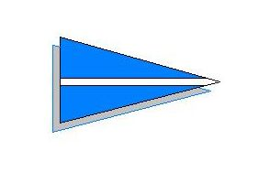
ELTON BOAT CLUB
MOORINGS AT WARMINGTON MILL

FEES FOR THE YEAR 2020

PLEASE NOTE THAT FEES HAVE NOT BEEN INCREASED AS THE NEGOTIATIONS FOR THE LEASE HAVE NOT YET BEEN FINALISED.

MEMBERSHIP FEES
Annual Membership Subscriptions Fee (1 April-31 March) £30.00 per person

One off Joining Fee for New Adult Members £150.00 per person

Members elected after October 1st shall pay the joining fee and half the subscription applicable for the year. Anyone elected after January 1st shall pay the joining fee before becoming a member. Payment of the subscription fee would be due by 1st April. Junior members pay no fee

MOORING FEES
Annual Mooring Fee (1 April – 31 March) £180.00

One Off Mooring Allocation Fee £150.00

Moorings allocated in January or February will require payment of the Allocation Fee before taking up the mooring. Payment of the Mooring Fee would be due by 1 April.

HARBOURMASTER CHARGES
A Club Key is available to full Members. A deposit of £30.00 is required, refundable on return of the key.

Slipping fees (including pressure washer fuel) are £40 for Members and £75 for non-members, payable before slipping.

NOTES
1. Full payment of fees is due by 1 April each year. Late payment carries an administration fee of £50.

PAYMENT
All fees are payable to Elton Boat Club and can be made directly into the Elton Boat Club account using your name as reference.

Account: Elton Boat Club
Account Number: 05343178
Sort Code: 54-21-38

